**DEPARTMENT OF INFORMATION TECHNOLOGY**

**Course Name and Code:** Data Structures Lab **(**ITL302)

**Semester:** III (SYIT)

**Academic Year:** 2024-25 (Odd Semester)

**Experiment No. 01**

**Aim:** **Implementation of Stack using an array for real-world application.**

**Code:**

#include <stdio.h>

#include <stdlib.h>

struct Stack

{

int N;

int S[100];

int Top;

};

void Push(struct Stack * Sptr, int ele);

int Pop(struct Stack* Sptr);

int Peep(struct Stack * Sptr, int index);

void Display(struct Stack * Sptr);

int main()

{

struct Stack St;

printf("Enter size of stack: ");

scanf("%d", &(St.N));

St.Top = -1;

int choice, temp;

while(1)

{

printf("\nChoose an option for the stack: \n");

printf("1. Push\n2. Pop\n3. Peep\n4. Display\n5. Exit\n");

scanf("%d", &choice);

switch(choice)

{

case 1:

printf("Enter element to be pushed: ");

scanf("%d", &temp);

Push(&St, temp);

break;

case 2:

printf("Popped Element: %d", Pop(&St));

break;

case 3:

printf("Enter index of element to be peeped: ");

scanf("%d", &temp);

printf("Peeped Element: %d", Peep(&St, temp));

break;

case 4:

printf("Stack: ");

Display(&St);

break;

default:

return 0;

}

}

return 0;

}

void Push(struct Stack * Sptr, int ele)

{

if(Sptr->Top >= Sptr->N - 1)

{

printf("Stack Overflow Error!");

exit(-1);

}

Sptr->Top += 1;

Sptr->S[Sptr->Top] = ele;

}

int Pop(struct Stack * Sptr)

{

if(Sptr->Top < 0)

{

printf("Stack Underflow Error!");

exit(-1);

}

Sptr->Top -= 1;

return Sptr->S[Sptr->Top + 1];

}

int Peep(struct Stack * Sptr, int index)

{

int PeepIndex = Sptr->Top - index + 1;

if(PeepIndex < 0)

{

printf("Peep Underflow Error!");

exit(-1);

}

return Sptr->S[PeepIndex];

}

void Display(struct Stack * Sptr)

{

printf("[");

for(int i = 0; i <= Sptr->Top; i++)

printf("%d, ", Sptr->S[i]);

printf("]\n");

}

**Output:**

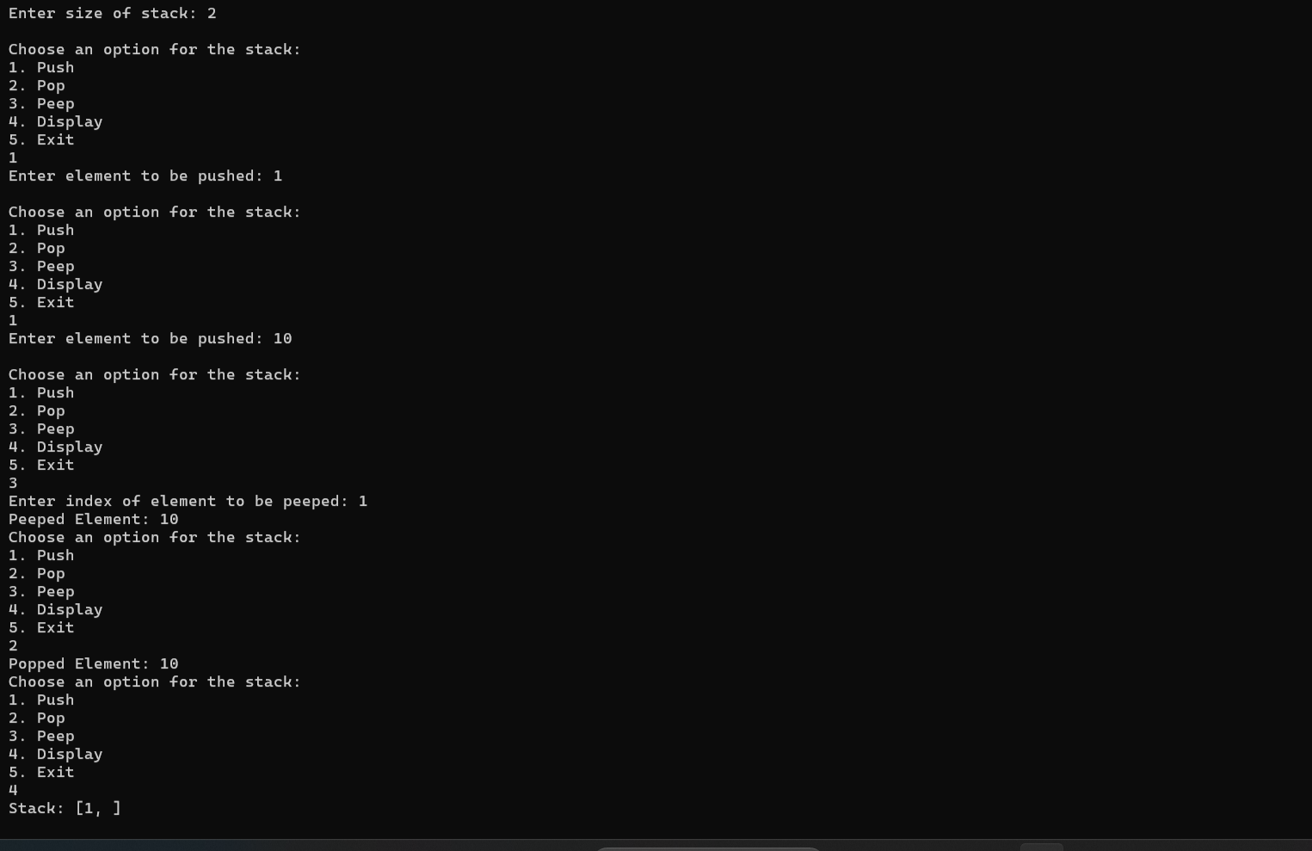

**Submitter Details:-**

**Name:** Faizan Dodiya

**Roll No:** 24

**Div/Batch :** A/ S-2